_____________________________________________

One final concept sits above everything
If I had to give the entire operating philosophy one rule, it would be:

NOTHING IMPORTANT CAN EXIST WITHOUT A CLOSED LOOP.
Every important TASK:
Assigned → Done → Proven → Verified → Closed
Every unfinished task:
Missed → Carried → Reassigned/Rescheduled → Followed Up → Closed
Every problem:
Detected → Owned → Corrected → Verified → Closed
Every exception:
Detected → Escalated → Decision → Action → Verified → Closed
Every recurring failure:
Detected → Root Cause → Permanent Fix → Recheck → Closed
Every SOP change:
Changed → Approved → Communicated → Trained → Adopted → Audited → Closed
Every handoff:
Transferred → Acknowledged → New Owner → Closed
That principle is more important than any individual PDF.

So are you fundamentally missing anything major?
After adding Priority, Decision Authority, Handoffs, Continuity/Backup, Capacity Control, and System Adoption: I don’t see another major fundamental operating concept missing.
There will always be specific SOPs you discover later—something involving a vendor, a particular product, a weird customer situation, a new law, etc. That’s normal.
But I would stop trying to reach “every conceivable SOP.”
Your architecture itself can now catch missing SOPs:
Something happens that isn’t covered → exception gets logged → management handles it → recurring problem identifies gap → SOP gets created → people trained → system updated.
That’s actually better than trying to predict every possible scenario today.
The ultimate goal isn’t a system that already knows every future problem.
It’s a system that cannot easily lose a task, problem, failure, responsibility, or lesson—and gets stronger whenever something new happens.
That’s the point where I’d consider the fundamentals of the seven-store operating architecture complete

The 6 remaining fundamentals I’d make explicit

1. PRIORITY SYSTEM — what’s most important when everything can’t get done?
This is the biggest fundamental I think is still underdeveloped.
You can have perfect task assignment and carryover, but eventually a manager will have:
customer line
employee call-out
shipment arriving
marketing task due
cleaning task due
maintenance issue
owner task due
They need to know what wins.
Create a universal priority hierarchy, approximately:
P0 — Immediate safety/legal/business continuity
↓
P1 — Store cannot operate / major money or security exposure
↓
P2 — Customer-facing/store-critical operations
↓
P3 — Deadline-sensitive operational work
↓
P4 — Normal recurring work
↓
P5 — Improvement/nonurgent projects
This also fixes a weakness in carryover accountability: sometimes a missed task is actually the correct management decision because something more important happened.
Without priority rules, employees can technically follow every SOP and still make bad business decisions.

2. DECISION RIGHTS / AUTHORITY MATRIX — who is allowed to decide?
You’ve covered who is responsible, but responsibility and authority aren’t identical.
A manager needs to know:
Can I give this refund?
Can I close the store?
Can I send an employee home?
Can I call a repair company?
Can I spend $300?
Can I discount this product?
Can I transfer inventory?
Can I approve overtime?
Can I ban a customer?
Can I change someone’s schedule?
Can I terminate someone?
Can I change a price?
You need a simple:

DECISION AUTHORITY MATRIX
Employee can decide → X
Manager can decide → X
Operator approval required → X
Owner approval required → X
This prevents two opposite problems:
Managers making decisions they shouldn’t
and
Managers calling ownership about every tiny decision.
For a system intended eventually to reduce owner involvement, this is extremely important.

3. HANDOFF SYSTEM — responsibility changing between people
Your carryover system handles unfinished work extremely well.
But there’s a related problem:
What happens when responsibility changes hands?
Examples:
Morning → evening shift
Manager → assistant manager
Manager goes on vacation
Employee quits
Store manager changes
Operator is unavailable
Office person goes on leave
There should be a standard:
OPEN ITEMS → CASH/INVENTORY ISSUES → STAFFING ISSUES → CUSTOMER ISSUES → MAINTENANCE → EXPECTED DELIVERIES → DEADLINES → SPECIAL INSTRUCTIONS → RECEIVER ACKNOWLEDGES
The receiver explicitly accepts the handoff.
This creates an important rule:
Responsibility is not transferred until the receiving person acknowledges it.
That closes another place where work can disappear.

4. BUSINESS CONTINUITY / BACKUP OWNERSHIP
This is different from emergency SOPs.
Ask this question for every critical responsibility:
What happens if the person responsible disappears tomorrow?
Manager sick?
Who runs store?
Operator unavailable?
Who handles manager escalation?
Payroll person unavailable?
Who processes payroll?
Only key holder doesn’t show?
Who has backup access?
Vendor unavailable?
Who is secondary vendor?
Internet fails?
Backup process?
Every critical company function should have:
PRIMARY OWNER → BACKUP OWNER → BACKUP PROCEDURE
Your access/offboarding and exception systems cover pieces of this, but I would explicitly make continuity a fundamental design principle.
A seven-store operation shouldn’t have important single points of failure.

5. CAPACITY / WORKLOAD CONTROL
This one is easy to overlook.
A perfect accountability system can become ineffective if management continuously assigns more work than employees can realistically execute.
Suppose a manager receives:
4 management tasks
3 carryovers
2 employee problems
shipment
inventory count
marketing verification
maintenance problem
store visit
Then they fail six things.
Is that a discipline problem?
Maybe.
Or the system is overloaded.
Therefore periodically measure:
Assigned → Completed → Carried → Overdue
By employee and manager.
If carryovers constantly increase, ask:
People problem? Training problem? Priority problem? Too many tasks? Unrealistic deadlines? Understaffing? Bad workflow?
This protects your accountability system from becoming simply “assign everything and punish misses.”

6. SYSTEM ADOPTION / COMPLIANCE CONTROL
This is subtle but crucial.
You can build this entire operating system and still have:
Manager uses old WhatsApp method.
Another manager uses the new checklist.
One employee never opens the SOP.
Someone maintains a private spreadsheet.
Another person uses an old PDF.
So when a new system goes live, it needs an implementation loop:
SYSTEM APPROVED
↓
Old process retired
↓
Affected people notified
↓
Training completed
↓
Acknowledgment
↓
Go-live date
↓
First-week verification
↓
30-day adoption audit
↓
Old copies removed
↓
SYSTEM OFFICIALLY EMBEDDED
Your document-control plan already recognizes versioning and retraining after changes.
Final Missing doc.pdf
I’m suggesting you elevate adoption itself into a fundamental control.
Because writing the system and implementing the system are two different things.

With those additions, I think your fundamental architecture is complete
I would organize the fundamentals into 5 master layers.

LAYER 1 — DIRECTION
Standard — What does correct look like?
Priority — What matters most?
Authority — Who can decide what?
Ownership — Who ultimately owns the result?

LAYER 2 — EXECUTION
Trigger/Frequency — When does it happen?
SOP — How exactly is it done?
Recurring Calendar — Makes recurring work appear automatically.
Handoff — How responsibility transfers.
Backup/Continuity — Who takes over if the normal person cannot.

LAYER 3 — CONTROL
Proof — Evidence it happened.
Verification — Supervisor confirms it.
Employee → Manager — Associate execution control.
Manager → Operator/Owner — Management execution control.
Carryover — Unfinished work survives shifts/days.
Escalation — Serious/repeated problems move upward.
Exceptions — Abnormal situations have defined responses.

LAYER 4 — ACCOUNTABILITY & PERFORMANCE
Accountability — Failure has a response.
Audit — Reality independently checked.
KPIs — Results measured.
Store Scorecard — Location health.
Manager Scorecard — Leadership performance.
Capacity — Determine whether workload itself is realistic.

LAYER 5 — SELF-IMPROVEMENT
Recurring Problem Detection
↓
Root Cause
↓
Corrective Action
↓
SOP/System Change
↓
Version Control
↓
Training
↓
Adoption Verification
↓
Reaudit
↓
Continuous Improvement
Your existing root-cause concept already supports this approach: immediate fix → root cause → system/process failure → permanent corrective action → responsible person → deadline → verification.

________________________________________________________________________________________________________________

Solving local to manager issue

The system you are building is very good overall. I would keep the fundamental concept. I would not replace it with a completely different system.
But I would upgrade it one more level.
The best version is not an SOP system. It is a Retail Execution & Control System.
Your current documents already discovered the core principle:
DOCUMENT → ASSIGN → EXECUTE → PROVE → SUPERVISE → AUDIT → MEASURE → CORRECT → IMPROVE → UPDATE → REPEAT.
Final Missing doc.pdf
That is very close to how I would design the company from scratch. Current multi-location retail operations guidance similarly emphasizes that SOPs alone aren’t enough: standardized tasks, verification, corrective-action closure, role-based responsibility, centralized documents, and dashboards are what turn standards into actual execution.

The one major upgrade I recommend
I would organize the company around three interconnected systems, rather than treating everything as one giant SOP library.

SYSTEM 1 — KNOWLEDGE SYSTEM
“How should the company operate?”
This contains:
Policies
SOPs
Training
Product knowledge
Sales standards
Marketing procedures
Hiring procedures
Cash procedures
Inventory procedures
Emergency procedures
Manager procedures
Reference material
This is your company brain.
People open this when they need to learn something or understand how something works.

SYSTEM 2 — EXECUTION SYSTEM
“What does everyone need to do right now?”
This is what employees and managers actually live inside.
Associate Daily Flow
Manager Daily Flow
Operator Daily Flow
Opening checklist
Closing checklist
Cleaning calendar
Marketing calendar
Inventory tasks
Manager tasks
Weekly tasks
Monthly tasks
And then:
WHEN X HAPPENS → automatically use X procedure.
Shipment arrives → Receiving SOP
Employee calls out → Coverage SOP
Employee hired → Onboarding workflow
Employee terminated → Offboarding workflow
Cash short → Cash Discrepancy SOP
Customer complaint → Complaint SOP
POS down → Downtime SOP
Theft suspected → Loss Prevention SOP
The critical distinction is:
Knowledge system = what/how.
Execution system = who/when.
Your documents already move strongly in this direction by separating recurring work from “when it comes up” work and calling for separate master flows for employees, managers and owners.
Final Missing doc.pdf

SYSTEM 3 — CONTROL SYSTEM
“How does ownership know Systems 1 and 2 are actually working?”
This is the piece I would emphasize most.
Associate completes
↓
Manager verifies
↓
Operator verifies manager
↓
Independent/random audit
↓
Scorecard measures result
↓
Problem gets flagged
↓
Corrective action assigned
↓
Deadline established
↓
Recheck occurs
↓
Problem closes OR escalates
↓
Recurring problem triggers root-cause analysis
↓
System/SOP changed if necessary
This is your control tower.
Your documents already recognize the chain:
Associate → Manager → Operator → Ownership, together with independent/random auditing.
Final Missing doc.pdf
I would make that one of the most important systems in the entire company.

The final model
Think of your seven stores like this:
COMPANY STANDARDS
↓

KNOWLEDGE
“What is the correct way?”
↓

EXECUTION
“Who does what and when?”
↓

PROOF
“Did they actually do it?”
↓

SUPERVISION
“Did the manager verify it?”
↓

CONTROL
“Did the manager/operator actually maintain the system?”
↓

PERFORMANCE
“Did the system produce the desired result?”
↓

CORRECTION
“What isn’t working?”
↓

IMPROVEMENT
“How do we prevent it from happening again?”
↓
UPDATED COMPANY STANDARD
↓
Repeat forever.
That is stronger than merely saying “we have an SOP for everything.”

There are 6 principles I would make non-negotiable
These are more important than adding another 30 documents.

1. Every responsibility has ONE primary owner.
Never:
Billy and manager should handle inventory.
Instead:
Manager owns store inventory accuracy.
Operator supervises it.
Associate executes assigned counts.
If everybody owns something, nobody truly owns it.

2. Every recurring responsibility appears automatically.
Employees should not remember systems.
The system remembers for them.
Monday 10 AM → task appears.
Closing → checklist appears.
30th → monthly system audit appears.
New hire → onboarding workflow starts.
Shipment arrives → receiving workflow starts.
The strongest multi-location systems increasingly use recurring role-based task assignment and escalation rather than relying on individual managers to remember requirements.

3. Manage by exception.
This is a major improvement I would make for you as owner.
You should NOT spend your day looking through:
7 stores × 20 tasks = 140 completed tasks.
You should see:
GREEN — 132 completed correctly
RED — 8 exceptions
Then:
Store 2 — cash variance
Store 4 — manager missed audit
Store 5 — inventory discrepancy
Store 6 — marketing missed
Store 7 — maintenance overdue
Your attention goes to the 8 failures, not the 132 successes.
That is how your system can scale beyond seven stores.

4. Proof is not the same as performance.
This distinction is extremely important.
Employee posts flyer photo.
Proof: flyer was distributed.
But:
Did traffic increase?
Employee posted social content.
Proof: content was posted.
But:
Did views/followers/store visits improve?
Manager says inventory was completed.
Proof: count exists.
But:
What is inventory accuracy/shrink?
So measure BOTH:
Execution KPI
Did the system happen?
AND
Outcome KPI
Did it produce the result?
Your Progress document already pushes toward ownership measuring results rather than simply asking whether an activity occurred.
progress.pdf

5. Never let a failure disappear.
This might be the most important rule in your entire company.
NO OPEN LOOP MAY DISAPPEAR.
Something wasn’t completed?
It doesn’t vanish tomorrow.
It becomes:
OPEN ISSUE
Owner: John
Problem: Missing merchandise count
Original deadline: Tuesday
Corrective deadline: Wednesday 12 PM
Status: OPEN
Escalation: Manager
Proof required: Count sheet
Tomorrow:
Still unfinished?
ESCALATE.
Your Unfinished Work system already proposes essentially this: reason → new deadline → responsible person → escalation → follow-up.
Final Missing doc.pdf
I would make this company-wide.

6. The system must continuously simplify itself.
This sounds counterintuitive because you’re building more documents.
But every monthly system review should ask:
What can we DELETE?
Not just:
What should we ADD?
Ask:
Is this SOP actually used?
Does this checklist duplicate another?
Does this report cause an action?
Can this task be automated?
Can two documents become one?
Is management collecting information nobody looks at?
Is this requirement worth employees’ time?
Current operations guidance warns that poorly designed processes remain poor even when digitized and that audits/KPIs should drive action rather than bureaucracy.
That’s extremely relevant to what you’re building.

What I would NOT do
I would not try to make the system so detailed that employees need to read 30 pages every shift.
That’s where a sophisticated system can actually become worse.
An associate should primarily see:
TODAY
8 tasks.
Not:
Here’s our 350-page Retail Operations Manual.
The 350-page system exists behind those eight tasks.
Same for managers.
Their daily interface should be simple even though the backend system is extremely sophisticated.
That’s one of the most important design principles I’d use.

And I would not have ownership micromanage seven stores
Your architecture should eventually look like:
OWNER
↓
OPERATING PARTNER / OPERATIONS LEADER
↓
7 STORE MANAGERS
↓
SHIFT LEADS / ASSOCIATES
The owner manages:
People
Numbers
Exceptions
Major decisions
Manager/operator performance
Systems
Growth
The owner shouldn’t be checking whether Store #4 cleaned a showcase Tuesday night.
If that reaches ownership regularly, the manager/operator control layer failed.
Your own system correctly says your role should increasingly become supervising the supervisors, rather than personally supervising every SOP.
Final Missing doc.pdf

I would also add one very powerful measurement

STORE HEALTH SCORE
Every store gets a weekly score, for example:
Sales Performance — 25%
Inventory/Shrink — 15%
Employee/Staffing — 10%
Marketing Execution — 10%
Cleaning/Store Standards — 10%
Cash Controls — 10%
SOP Compliance — 10%
Customer Experience — 5%
Maintenance/Compliance — 5%
= 100% STORE HEALTH
Then:

90–100
Excellent

80–89
Healthy

70–79
Needs attention

<70
Corrective Action Plan
You already planned store ranking/performance comparison and corrective plans for persistently underperforming stores.
Final Missing doc.pdf
I would turn that into one of ownership’s primary views.

Then have a Manager Health Score
Separate from store performance.
Because a manager can temporarily inherit a bad store.
Measure:
Task completion
Proof accuracy
Employee management
Training completion
Store standards
Inventory accuracy
Communication
Deadline compliance
Sales improvement
Problem resolution
Audit performance
Repeat failures
Now you’re measuring both:
STORE PERFORMANCE
and
PERSON RESPONSIBLE FOR STORE PERFORMANCE.
That makes accountability much cleaner.

One more major improvement: test it before calling it finished
Don’t finish all the PDFs and immediately deploy everything across seven stores.
I would take one store and run the entire operating system for 2–4 weeks.
Pretend ownership cannot intervene.
Observe:
What questions does manager ask?
What does employee misunderstand?
Which SOP can’t they find?
Which task gets forgotten?
What requires owner intervention?
What proof is fake/useless?
What takes too long?
What checklist is annoying?
What isn’t being supervised?
What problem has no SOP?
What SOP isn’t practical in reality?
Then fix it.
Then test at a second store.
Then standardize across seven.
Current multi-location guidance similarly recommends piloting a subset of locations, refining workflows, standardizing audits, and only then expanding.
That is how you find the gaps that brainstorming will never reveal.

So, is there a better system?
Not fundamentally.
I wouldn’t throw yours away and replace it.
I’d evolve it from:
“We have an SOP/document for everything.”
into:

THE 7-STORE RETAIL EXECUTION & CONTROL SYSTEM
Built on three engines:
1. KNOWLEDGE
How everything works.
2. EXECUTION
Who does what, when, with what proof.
3. CONTROL
Verification, audits, KPIs, exceptions, accountability and continuous improvement.
And underneath everything:
STANDARD → ASSIGN → EXECUTE → PROVE → VERIFY → MEASURE → FLAG EXCEPTION → CORRECT → RECHECK → IMPROVE
If you get that architecture working properly, I would consider it a genuinely strong operating model for seven stores. More importantly, it would be designed so adding store #8, #15, or #30 does not require ownership to proportionally increase its involvement.
The real test of whether you’ve succeeded isn’t “Do we have an SOP for everything?”
It’s:
Can an ordinary competent manager run one of these stores correctly for 30 days without asking ownership how to handle routine operations—and can ownership know which of the seven stores is slipping without personally visiting or chasing people for answers?
If the answer becomes yes, your system is doing what it’s supposed to do.
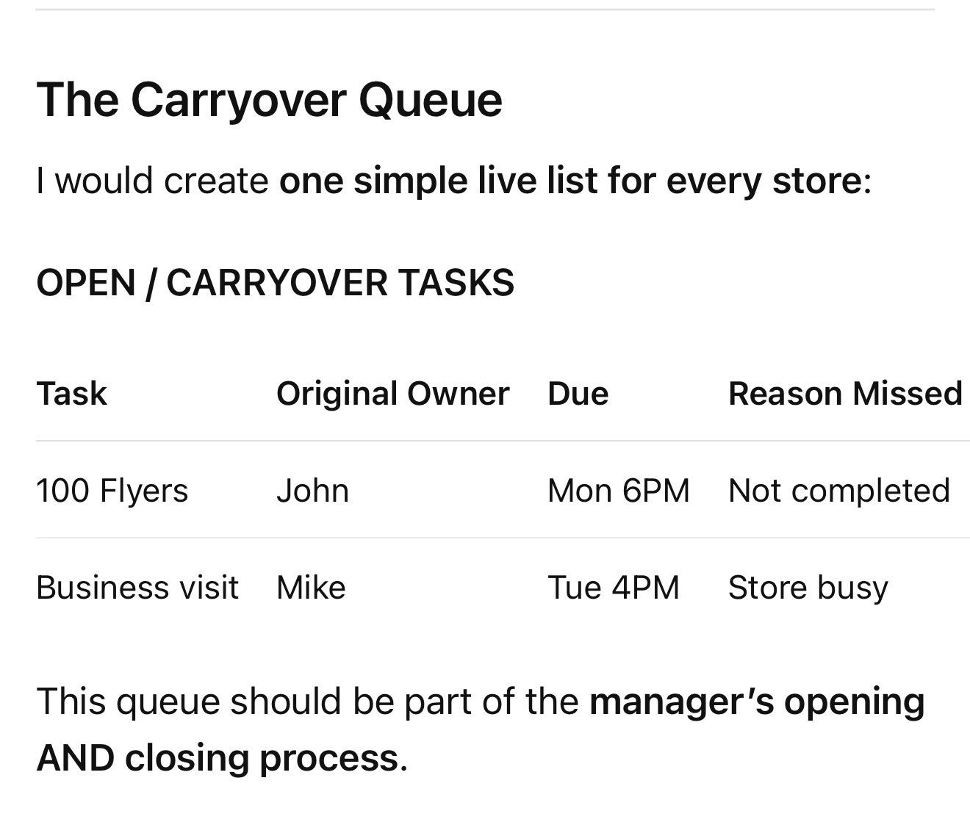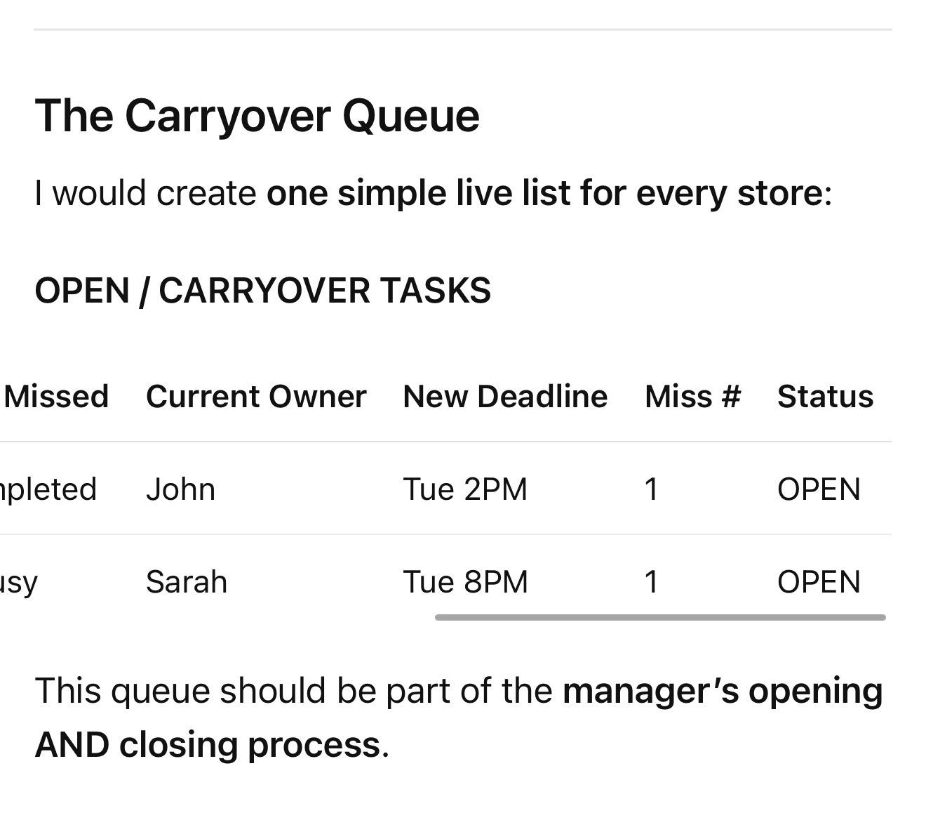

This queue should be part of the manager’s opening AND closing process.
So yesterday’s unfinished work physically enters today’s workflow.
Your existing system already says unfinished work needs a new deadline, responsible person, escalation level and follow-up.
Final Missing doc.pdf
Now you’re operationalizing it.

I would use a 3-level escalation

MISS #1 — CARRYOVER
Employee doesn’t complete task.
Employee reports it → manager reviews reason → new deadline/owner assigned → task enters Carryover Queue.
If legitimate reason: no automatic punishment necessary.
If employee-caused: record performance miss according to your accountability system.

MISS #2 — ESCALATION
The task is still incomplete at its new deadline.
Now manager must ensure someone completes it, rather than simply pushing it forward indefinitely.
Manager:
Reassigns to another associate OR completes it if necessary
- records second failure
- documents why it failed twice
- addresses original employee’s performance
- notifies operator/owner through exception reporting.
The task doesn’t disappear just because responsibility changed.

MISS #3 should almost never exist.
If a business task has reached a third deadline, you now have a management failure, not merely an associate failure.
At that point:
Operator intervention → immediate completion → root-cause review.
Why did the manager allow a store-level task to remain unfinished through two deadlines?
Your broader system already says repeated failures shouldn’t merely be fixed occurrence by occurrence; they should trigger root-cause and permanent corrective action.
Final Missing doc.pdf

The owner should NOT track individual tasks manually
This is another change I’d make to your idea.
You said:
“owner and manager keep track of that”
Manager = yes.
Owner/operator = monitors the exceptions, not every individual task.
For seven stores, imagine:
7 stores × 5 unfinished items = 35 tasks.
You don’t want ownership maintaining a mental list of 35 carryovers.
Instead ownership sees:

DAILY UNFINISHED WORK DASHBOARD
Store A: 0 open
Store B: 2 open — oldest 1 day
Store C: 0
Store D: 🔴 1 overdue twice
Store E: 3 open
Store F: 0
Store G: 1 open
Owner/operator primarily investigates red exceptions.
The manager owns the actual carryover queue.

Add an aging rule
This makes the system much stronger.
Every open task gets an age:
GREEN: Still within revised deadline
YELLOW: Missed original deadline once
RED: Missed revised deadline / second failure
CRITICAL: Open beyond maximum acceptable time or business-critical task overdue
Nothing should sit OPEN indefinitely.

Also distinguish “employee failure” from “operationally impossible”
This matters for fairness and for diagnosing your company.
Employee didn’t distribute flyers because they spent the shift on their phone?
Employee performance failure.
Employee couldn’t distribute flyers because the only employee in the store couldn’t leave the premises?
System/scheduling failure.
Employee couldn’t make marketing material because printer was broken?
Resource/maintenance failure.
Task was assigned at 8 PM but realistically takes three hours?
Management/planning failure.
Therefore every carryover gets a Reason Code:
EMPLOYEE
MANAGEMENT
STAFFING
CUSTOMER VOLUME
MATERIAL/RESOURCE
VENDOR/EXTERNAL
TECHNOLOGY
OTHER
Now after 30 days you can discover:
42 marketing tasks were carried over.
24 because employees failed.
11 because stores were understaffed.
7 because management assigned them too late.
That’s much more valuable than simply punishing 42 misses.

Most importantly: separate TASK COMPLETION from ACCOUNTABILITY
I would put this rule in bold in the system:
Reassigning an unfinished task does not erase accountability from the employee who originally failed to complete it.
Otherwise the records become distorted.
John failed the marketing task.
Sarah completed it.
The operational record says:
TASK = COMPLETED ✓
But John’s performance record says:
ASSIGNED TASK = MISSED ✗
Sarah may receive:
RECOVERY COMPLETION ✓
Those should be separate.
Your current manager performance system already treats work that is late, incomplete, or lacks proof as negative performance and formally reviews execution.
Operator System.pdf
Apply the same principle downward.

Final flow I’d implement
MARKETING TASK ASSIGNED
↓
Employee works task
↓

COMPLETED?
YES
Proof submitted → Manager verifies → CLOSED ✓
NO
↓
Employee submits Incomplete Task Report before shift end
↓
Manager identifies reason
↓
Manager chooses:
FINISH NOW / CARRY TO NEXT SHIFT / REASSIGN
↓
NEW OWNER + NEW DEADLINE MUST BE ENTERED
↓
Task automatically enters OPEN TASK / CARRYOVER QUEUE
↓
Next manager opening review sees it
↓

COMPLETED BY NEW DEADLINE?
YES
Proof → Manager verification → CLOSED ✓
Original employee miss remains in performance record if appropriate.
NO
↓

RED ESCALATION
Manager must ensure task gets completed/reassigned immediately.
Employee failure addressed.
Operator notified through exception reporting.
↓
If still unresolved:

MANAGEMENT FAILURE / ROOT-CAUSE REVIEW
↓
Correct problem → verify → close.

One company rule summarizes the whole thing
NO TASK DIES AT THE END OF A SHIFT.
Every assigned task must eventually terminate as:
✓ COMPLETED & VERIFIED
or
✕ FORMALLY CANCELLED BY AUTHORIZED MANAGEMENT WITH REASON.
Until one of those happens, the task remains OPEN and belongs to a named person with a deadline.
That is stronger than simply saying “employee does it next shift, and if not manager does it.” Your original idea has the correct principle; this adds formal ownership, deadlines, carryover tracking, escalation, separation of completion from accountability, and management-by-exception so nothing can quietly disappear.

________________________________________________________________________________________________________________

Manager to owner

For Manager → Owner, I would use the same principle, but the system should be more exception-based.
The owner should not become the manager’s version of the manager. If a manager has 15 unfinished items across a week, the owner shouldn’t personally chase every item. The manager owns store execution; the owner/operator supervises whether the manager is successfully closing those loops.
Your existing documents already establish that managers are expected to complete assigned work by deadlines, communicate progress, submit proof, and maintain standards without constant reminders.
Operator System.pdf

Manager → Owner unfinished-task system
The core rule should be:
NO MANAGER TASK CAN DISAPPEAR. Every unfinished manager responsibility becomes an OPEN ITEM with an owner, reason, new deadline, proof requirement, and escalation status.
The flow:
MANAGER TASK ASSIGNED
↓
Manager works on it
↓

Completed by deadline?
YES → Submit proof → Owner/operator verifies where required → CLOSED
NO → Manager must report it before the deadline/EOD → task automatically becomes OPEN / CARRYOVER
↓
Manager reports:
Task: Complete store merchandise reset
Original deadline: Wednesday 6 PM
Status: Incomplete
Reason: Shipment arrived late
What was completed: 70%
Remaining: Back wall + disposable section
New proposed deadline: Thursday 1 PM
Proof: Current photos
↓
Owner/operator either:
APPROVE NEW DEADLINE
CHANGE DEADLINE
REPRIORITIZE
REASSIGN
ESCALATE
↓
Task stays OPEN until verified complete.
This directly extends your existing unfinished-work concept of reason → new deadline → responsible person → escalation → follow-up.
Final Missing doc.pdf

But there’s an important difference from Associate → Manager
With an associate, the manager may eventually take over the actual work because the store needs the task finished.
With Manager → Owner, the owner generally should NOT take over the manager’s task.
Otherwise you create a terrible cycle:
Manager fails → Owner does manager’s work → Manager learns owner will rescue them.
Instead:
Manager fails → task remains manager’s responsibility → operator/owner increases supervision → corrective action → escalation if repeated.
Only if the business is at risk should ownership/operator step in or assign someone else.
And even then:
Reassignment solves the business problem. It does NOT erase the manager’s failure.

I would give managers 3 levels

LEVEL 1 — FIRST MISS / NORMAL CARRYOVER
Manager reports before deadline.
There is a legitimate reason.
New deadline assigned.
Task remains OPEN.
No major escalation necessary unless the miss was avoidable.

LEVEL 2 — SECOND MISS / OVERDUE
Manager misses revised deadline.
Now it becomes a RED ITEM.
Operator/owner gets alerted.
Manager must explain:
Why did it fail twice? Exactly what remains? When will it be completed? What is preventing completion? What corrective action is being taken?
It also enters the manager’s performance/accountability record.

LEVEL 3 — REPEATED FAILURE / MANAGEMENT FAILURE
If the same task misses again—or the manager develops a pattern of carryovers—the issue is no longer:
“Merchandise reset isn’t finished.”
The issue becomes:
“Manager cannot reliably execute assigned responsibilities.”
Now trigger your Manager Consequence / Corrective Action system.
Your existing architecture already says recurring failures should trigger root-cause analysis rather than simply fixing each occurrence.
Final Missing doc.pdf

Owner should have ONE Manager Carryover Dashboard
Don’t have unfinished work scattered through WhatsApp conversations.
For seven stores, ownership/operator should have something like:

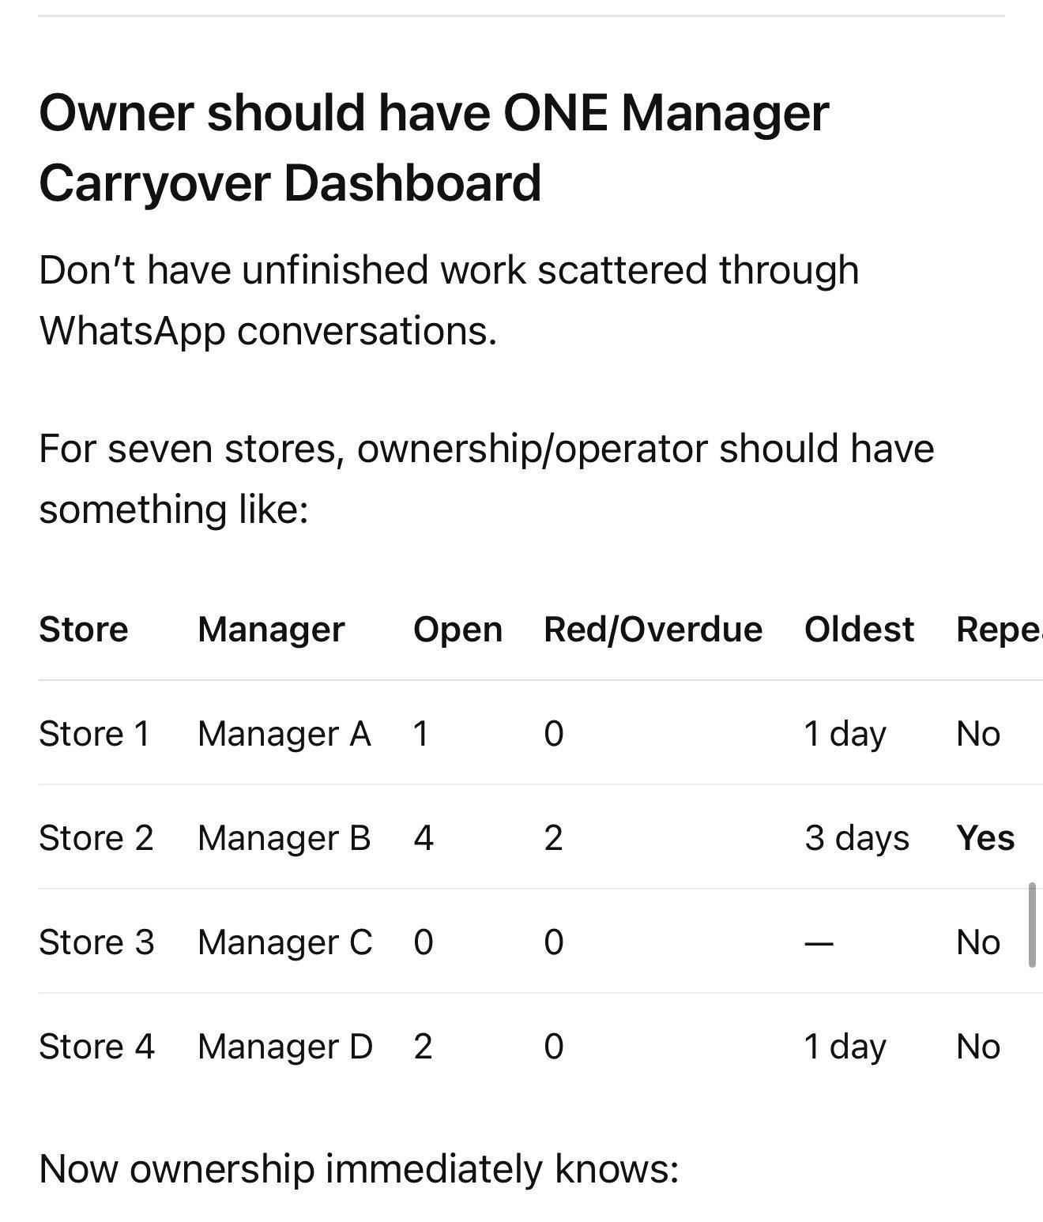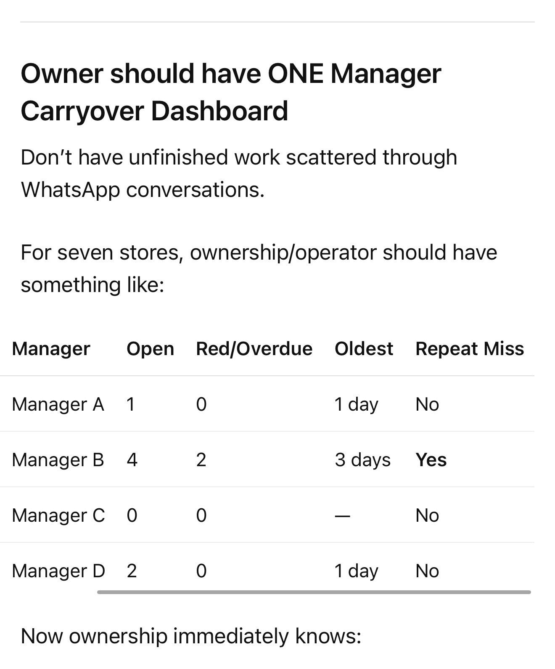

Now ownership immediately knows:
Store 2 needs attention.
Instead of reading 100 messages.

Manager EOD should have a very small unfinished-work section
I wouldn’t make managers write giant reports every night.
At closing:

OPEN ITEMS
1. What wasn’t completed today?
2. Why?
3. What is the new deadline?
4. Who owns it?
5. Is owner/operator action needed? YES / NO
That’s enough.
If nothing is open:
OPEN ITEMS: NONE ✓
Now the manager has explicitly certified that there is no forgotten work.

Next morning matters even more
The manager’s next-day flow should begin:

1. OVERDUE / CARRYOVER ITEMS
before

2. NEW DAILY TASKS
Unless a new task has greater business priority.
Otherwise you create the common problem:
Monday’s unfinished work gets buried under Tuesday’s new work.
Your own system specifically identified this risk: unfinished work needs a carryover mechanism so it doesn’t disappear between days.
Final Missing doc.pdf

And Owner → Manager should have a Follow-Up Queue
This is the other half you’re talking about.
Owner says:
“Fix the broken exterior light by Friday.”
That should not live only in a text message.
It becomes:
TASK: Exterior lighting repair
Store: X
Assigned: Manager
Assigned by: Owner/operator
Deadline: Friday
Proof: Working-light photo/invoice
Status: OPEN
The owner doesn’t need to remember Friday.
The system remembers Friday.
Friday:
Completed → proof → CLOSED
Not completed → automatically remains OPEN/OVERDUE → follow-up required.
That’s the fundamental concept.

I would actually have 3 queues
For the entire seven-store operation:

1. ASSOCIATE → MANAGER
Store-level unfinished work.
Manager owns this queue.

2. MANAGER → OPERATOR/OWNER
Manager-level unfinished work and important store exceptions.
Operator owns this queue.

3. OPERATOR/OWNER → OFFICE / OTHER
Company-level unresolved work.
Ownership/backend owns this queue.
Now nothing can fall between organizational levels.

One additional rule: not everything needs to reach ownership
This is critical.
Suppose:
Associate didn’t clean bottom showcase.
Employee reports it.
Manager reassigns it.
It gets completed next morning.
Owner doesn’t need to know.
But if:
Employee repeatedly fails
Manager isn’t following up
Store repeatedly misses marketing
Cash discrepancy occurs
Critical compliance task missed
Important inventory discrepancy exists
Manager misses revised deadline
Then it moves upward.
So use:

GREEN
Manager resolves internally.

YELLOW
Manager tracks; operator can see it.

RED
Operator/owner action required.

CRITICAL
Immediate owner notification.
That prevents your system from turning ownership into a giant customer-service desk for seven stores.

The full hierarchy becomes very clean
LOCAL EMPLOYEE
Task assigned
↓
Do it
↓
Proof
↓
Manager verifies
If unfinished:
Carryover Queue → new owner/deadline → manager follows up
↓
MANAGER
Owns all unresolved store-level items
↓
Completes manager responsibilities
↓
Reports exceptions / proof
If manager fails to close it:
Manager Carryover Queue → operator/owner supervision → corrective action
↓
OPERATOR / OWNER
Doesn’t chase every task.
Monitors:
Exceptions Overdue work Repeat failures Manager performance Store outcomes
↓
If something repeatedly fails
Root cause → corrective action → SOP/system improvement.
That fits your existing operating principle almost perfectly:
DOCUMENT → ASSIGN → EXECUTE → PROVE → SUPERVISE → AUDIT → MEASURE → CORRECT → IMPROVE → UPDATE → REPEAT.
Final Missing doc.pdf
The main thing I would avoid is Owner + Manager both “keeping it in mind.” That’s still dependent on human memory. Instead, one named person owns the item, one system holds the open item, one deadline exists, and the next level supervises by exception until it says CLOSED.

________________________________________________________________________________________________________________

Additions strength to it

The key is that the owner should not be managing a giant carryover list. The manager should be responsible for closing almost everything. Ownership should receive a very short daily control signal showing what failed, what is still open, and what actually needs intervention.
Your existing system already says managers should complete assigned work by deadlines, communicate progress, submit proof, and maintain standards without constant reminders.
Operator System.pdf

MANAGER → OWNER CLOSED-LOOP SYSTEM

Core rule
Nothing unfinished can disappear, but not everything unfinished needs owner involvement.
The system is:
ASSIGN → EXECUTE → VERIFY → CLOSE
If not completed:
MISS → LOG → RECOVERY PLAN → NEW DEADLINE → FOLLOW-UP → CLOSE / ESCALATE
And:
Every OPEN item must always have exactly ONE owner + ONE next deadline + ONE next action.
That eliminates the “I’ll remember it tomorrow” problem.

1. MANAGER OWNS THE STORE
This should be established first.
The manager isn’t simply responsible for their own four tasks.
The manager is responsible for making sure:
Employee tasks get completed
Marketing gets completed
Cleaning gets completed
Merchandise gets completed
Store problems get addressed
Open tasks get closed
Proof gets submitted
Failures get corrected
Your owner/operator isn’t supposed to discover routine failures.

Manager’s job:
EXECUTION + SUPERVISION + RECOVERY

Owner/operator’s job:
VERIFY + MEASURE + ESCALATE
That’s a major distinction.

2. ONE MANAGER DAILY CONTROL BOARD
Don’t make separate unfinished lists everywhere.
Each manager has ONE board/list containing:

TODAY
Everything due today.

OPEN
Anything started but unfinished.

OVERDUE
Anything past deadline.

WAITING
Cannot currently proceed because of vendor, shipment, owner approval, maintenance company, etc.

CLOSED
Completed + proof verified.
That’s it.
A task should never exist outside one of these states.

3. EVERY TASK MUST HAVE 6 THINGS
No vague task such as:
“Work on marketing.”
Instead:
TASK: Distribute 150 flyers
OWNER: Manager John
STORE: Hurst
DEADLINE: Wednesday 6 PM
STANDARD: 150 flyers distributed in approved locations
PROOF: Required photos/count
Now the task can actually be managed.

4. MANAGER DOES NOT WAIT UNTIL EOD TO REPORT A PROBLEM
This is an important change.
If a manager knows at 2 PM that a 5 PM task won’t happen, don’t wait until 10 PM.
Rule:
Once the manager reasonably knows a deadline will be missed, the exception must be reported.
This gives management time to save the result.
Example:
2:30 PM
INVENTORY TRANSFER AT RISK
Reason: Employee called out.
Deadline: 5 PM.
Recovery: Sarah arriving at 4 PM; completion expected 6 PM.
Owner action needed: NO.
Good.
Manager identified the problem before failure.
That’s much stronger than documenting failure afterward.

5. USE A VERY SHORT “MISS REPORT”
If something isn’t completed:

MANAGER MISS REPORT
TASK:
WHY NOT COMPLETED:
WHAT REMAINS:
NEW DEADLINE:
RECOVERY PLAN:
OWNER ACTION NEEDED: YES / NO
No paragraph.
No giant report.
30–60 seconds.
Your existing Unfinished Work concept already requires reason, new deadline, responsible person, escalation and follow-up.
Final Missing doc.pdf

6. THE MOST IMPORTANT PART: AUTOMATIC CARRYOVER
At the beginning of the next day:

OVERDUE/CARRYOVER comes BEFORE new normal work.
So the manager sees:

🔴 CARRYOVER
- Finish vape wall reset — due 12 PM
- Replace exterior light — due 3 PM

TODAY
- Merchandise list
- Marketing review
- Employee training
- Cleaning audit
Monday’s unfinished work cannot get buried under Tuesday.

7. DON’T ALLOW ENDLESS NEW DEADLINES
This is where the system becomes strong.
Managers shouldn’t be able to do:
Monday → “tomorrow.”
Tuesday → “tomorrow.”
Wednesday → “tomorrow.”
Thursday → “tomorrow.”
Use escalation levels.

LEVEL 0 — NORMAL
Completed by original deadline.
CLOSED.

LEVEL 1 — FIRST MISS
Task wasn’t completed.
Manager submits Miss Report.
Manager gets one revised deadline.
Status:

🟡 CARRYOVER
Manager still owns it.
If the reason was within their control, performance miss is recorded.

LEVEL 2 — REVISED DEADLINE MISSED
Now it automatically becomes:

🔴 OVERDUE
Manager cannot simply give themselves another deadline.
Operator/owner must review it.
Decision:
A. Manager completes immediately
B. Reassign
C. Additional resources provided
D. Legitimately reschedule
E. Cancel because task is no longer necessary
And manager receives accountability according to your consequence system where appropriate.

LEVEL 3 — CRITICAL FAILURE
A task that survives another deadline is no longer primarily a task problem.
It’s a management problem.
Now trigger:
Manager corrective action
Root-cause review
Higher supervision
Potential consequence
System/process correction
Your current system correctly recognizes that repeated failures should trigger permanent root-cause correction rather than simply fixing the same occurrence repeatedly.
Final Missing doc.pdf

8. SEPARATE TWO THINGS
This is extremely important.

TASK STATUS
Was the work eventually completed?
and

MANAGER PERFORMANCE
Did the manager execute correctly?
Example:
Manager misses merchandise display.
Operator sends another manager to complete it.

Business side:
Merchandise display = CLOSED ✓

Performance side:
Original manager = MISSED DEADLINE ✕
Never allow reassignment to erase accountability.
Otherwise managers can get bad tasks off their plate by failing them.

9. MANAGER EOD SHOULD BE EXTREMELY SHORT
I wouldn’t require another giant daily report.
Every manager sends one:

DAILY CLOSEOUT
TODAY: 8/9 completed
OPEN: 1
OVERDUE: 0
CRITICAL ISSUES: 0
OPEN ITEM: Exterior light — electrician scheduled tomorrow 11 AM.
OWNER ACTION REQUIRED: NONE
STORE STATUS: GREEN
Done.
If everything is good:
9/9 complete | 0 open | 0 overdue | No owner action | GREEN
Ownership can understand the store in five seconds.

10. USE A STORE STATUS SYSTEM
This would make seven stores dramatically easier to oversee.
Every manager ends the day:

🟢 GREEN
Everything important completed.
No significant overdue work.
No owner intervention needed.

🟡 YELLOW
Open issues exist but manager has them controlled.
Example:
Repair scheduled.
Shipment delayed.
Employee replacement being handled.
Owner doesn’t need to intervene.

🔴 RED
Owner/operator attention required.
Examples:
Repeated missed deadline
Cash discrepancy
Major staffing issue
Serious inventory discrepancy
Store cannot open
Compliance issue
Serious customer incident
Manager cannot solve problem
Now ownership sees:
Hurst — 🟢
Carrollton — 🟢
Grand Prairie — 🟡
Lancaster #1 — 🟢
Lancaster #2 — 🔴
Fort Worth — 🟢
Store 7 — 🟢
You immediately look at Lancaster #2.
That’s management by exception.

11. OWNER SHOULD HAVE ONE 10-MINUTE DAILY REVIEW
Not constantly checking everything.
At a fixed time, owner/operator opens:

7-STORE CONTROL BOARD
Look at only:
RED STORES
OVERDUE TASKS
SECOND MISSES
OWNER ACTION REQUIRED
CRITICAL INCIDENTS
MANAGERS WITH REPEATED FAILURES
Then close it.
Your goal should be that most days ownership sees:
7 stores
6 Green
1 Yellow
0 Red
3 Open
0 Overdue
Owner Action Required: 0
Done.

12. OWNER SHOULD NOT CHECK EVERY PROOF
This is important for scaling.

Employee
Completes task + submits proof.

Manager
Checks employee proof.

Operator
Checks manager execution and exceptions.

Owner
Checks performance, exceptions, patterns and audits.
Ownership can randomly audit proof, but shouldn’t approve 200 photos every day.
Your existing system correctly defines the supervision chain as Associate → Manager → Operator → Ownership and recommends independent/random audits.
Final Missing doc.pdf

13. ADD RANDOM OWNER AUDITS
This prevents managers from learning:
“Owner only checks red items, so I’ll make everything look green.”
Randomly select:
1–2 stores / areas
and inspect underlying proof.
For example:
Manager reported:
Cleaning ✓
Owner randomly checks cameras/photos/store.
Or:
Marketing ✓
Check actual proof.
Or:
Inventory ✓
Spot-check several SKUs.
This creates:
TRUST → VERIFY → RANDOMLY AUDIT
which is already a principle in your existing system.
Final Missing doc.pdf

14. WEEKLY MANAGER SCORECARD
Daily management should be operational.
Weekly management should identify patterns.
Every manager gets:
Tasks completed on time: 94%
Carryovers: 4
Overdue after revised deadline: 1
Unreported misses: 0
Employee-task verification: 98%
Store standards: 92%
Marketing execution: 95%
Inventory compliance: 97%
Open issues: 2
Repeated failures: 0
Now you’re not arguing based on feelings:
“I think this manager works hard.”
You have evidence.
Your existing manager-performance system already measures tasks completed/missed, marketing, store standards, sales and overall execution.
Operator System.pdf

15. ADD ONE VERY IMPORTANT KPI: RECOVERY RATE
This is something I’d add.
Managers will inevitably have problems.
A great manager isn’t someone whose store never has problems.
Measure:

RECOVERY RATE
Of tasks/issues that became OPEN, what percentage were resolved by the first revised deadline?
Example:
10 issues occurred.
9 resolved correctly on first recovery.
Recovery Rate = 90%.
That’s valuable because it measures:
When something goes wrong, can this manager actually fix it?

16. ALSO MEASURE “UNREPORTED FAILURE”
This should be treated more seriously than a normal reported miss.
There is a huge difference between:

Manager A
“I won’t finish this today. Here’s why and here’s my recovery plan.”
versus:

Manager B
Says nothing.
Owner discovers three days later that it wasn’t done.
Manager A had an execution problem.
Manager B has an execution + communication/control problem.
Therefore track:
Reported Miss
versus
Unreported/Discovered Miss
The second should escalate faster.

17. WEEKLY OPEN-LOOP SWEEP
Once a week, operator reviews:
ALL OPEN
ALL WAITING
ALL OVERDUE
ALL SECOND MISSES
ALL OWNER-ACTION ITEMS
Nothing gets to sit there for weeks.
Ask for each:
Why is this still open?
Then:
COMPLETE / REASSIGN / ESCALATE / CANCEL
No zombie tasks.

18. MONTHLY ROOT-CAUSE REVIEW
Don’t only ask:
Who failed?
Ask:
Why does this type of failure keep occurring?
Example:
30 days:
18 marketing carryovers.
Break them down:
9 — staffing
5 — employees
3 — poor scheduling
1 — materials
Now maybe your marketing SOP isn’t the problem.
Your staffing or scheduling system is.
That’s where your system starts improving the business, instead of merely policing people.

FINAL MANAGER → OWNER SYSTEM
I’d formally write it like this:

MANAGER CLOSED-LOOP CONTROL SYSTEM
1. ASSIGN
Every responsibility has owner + deadline + standard + proof.
↓
2. EXECUTE
Manager completes or supervises completion.
↓
3. EARLY WARNING
If deadline is at risk → manager reports before failure where reasonably possible.
↓
4. COMPLETE
Proof submitted → verified → CLOSED.
OR
↓
5. MISS
Incomplete Task Report.
Reason + remaining work + recovery plan + revised deadline.
↓
6. CARRYOVER
Automatically appears in next work cycle.
↓
7. FIRST REVISED DEADLINE
Completed → CLOSED.
Missed →
↓
8. RED ESCALATION
Operator/owner review required.
No self-extension.
↓
9. BUSINESS RECOVERY
Complete / reassign / resource / reschedule / cancel.
↓
10. ACCOUNTABILITY
Original failure remains attached to responsible manager.
↓
11. REPEAT FAILURE
Corrective Action / Manager Consequence System.
↓
12. WEEKLY REVIEW
Manager scorecard + recovery rate + open loops.
↓
13. MONTHLY REVIEW
Root causes + system improvements.

The three rules I’d put at the top

RULE 1
NO TASK DISAPPEARS.
Every task ends COMPLETED or formally CANCELLED.

RULE 2
NO TASK EXISTS WITHOUT ONE OWNER AND ONE DEADLINE.
“We’re working on it” is not a status.

RULE 3
OWNERSHIP MANAGES EXCEPTIONS AND MANAGERS — NOT EVERY TASK.
Managers run stores. Ownership verifies the management system.
That is the version I’d use. It is stronger but actually simpler because employees manage their work, managers manage store execution and recovery, the operator manages manager exceptions, and ownership can understand seven stores from one control view rather than chasing texts, photos and unfinished tasks individually.

________________________________________________________________________________________________________________

Yes. The two you just focused on are fundamental control mechanisms:
1. Employee → Manager: unfinished employee work cannot disappear.
2. Manager → Owner/Operator: unfinished manager/store work cannot disappear.
Those solve vertical accountability.
But after looking at the architecture you’ve built, I think there are several other mechanisms at the same level of importance. These aren’t “another SOP for refunds” or “another cleaning document.” They are the fundamental mechanisms that make all SOPs function.
Your own master document already points toward this distinction: a document becomes a system only when responsibility, timing, proof, supervision, measurement, and correction are attached.
Final Missing doc.pdf

The fundamental control systems I would require

1. Unfinished Work / Carryover System
You just built this. CRITICAL.
Nothing disappears between shifts or days.
MISS → LOG → NEW OWNER/DEADLINE → FOLLOW-UP → ESCALATE → CLOSE
This should operate at every level:
Employee → Manager
Manager → Operator
Operator → Owner/Office
Your master document already identified unfinished work specifically because incomplete work can otherwise disappear between days.
Final Missing doc.pdf

2. Supervision / Verification Chain
Also CRITICAL.
It’s not enough that someone reports completion.
Every major responsibility needs a verifier:
Employee executes
↓
Manager verifies
Manager executes/manages
↓
Operator verifies
Operator manages system
↓
Owner verifies outcomes
Then occasional independent/random audits.
Without this, you can have a perfect carryover system filled with inaccurate information.
Your existing documents already identify this hierarchy and the need for random audits.
Final Missing doc.pdf

3. Exception / Escalation System
I would consider this equally fundamental.
Your SOP tells someone what to do when everything is normal.
But operations constantly produce abnormal situations.
Employee doesn’t show.
Manager doesn’t show.
manager goes in vacation 1 week
Cash is short.
Shipment is wrong.
Store can’t open.
Customer threatens legal action.
Inventory doesn’t match.
Internet goes down.
Employee is suspected of theft.
The crucial question becomes:
When something abnormal happens, who needs to know, how quickly, and who has authority to make the decision?
You already proposed an Exceptions Manual using:
IF X HAPPENS → DO A → THEN B → NOTIFY C → DOCUMENT D.
Final Missing doc.pdf
I’d take it further and establish universal escalation levels:
LEVEL 1 — Manager handles
Routine operational issue.
LEVEL 2 — Operator notified
Significant issue / manager needs assistance.
LEVEL 3 — Owner involvement
Material financial, personnel, operational or compliance issue.
LEVEL 4 — Immediate escalation
Serious safety, legal, security, major financial or business-continuity event.
That way employees and managers aren’t deciding from scratch whether something is “important enough.”

4. Recurring Work / Calendar System
This is one of the biggest fundamentals.
Your SOP library answers:
How?
Your calendar/checklist system answers:
When?
If something must happen repeatedly, nobody should have to remember it.
Daily → automatically appears.
Monday → appears.
Every Friday → appears.
30th → appears.
Quarterly → appears.
Annually → appears.
Your existing system already recognizes that recurring requirements belong on daily/weekly checklists or constant calendars rather than relying on managers to remember them.
Final Missing doc.pdf
So:
If it repeats, schedule it.
That’s a company-wide rule I’d adopt.

5. Proof-of-Completion System
Another fundamental.
The company cannot operate on:
“Yeah, I did it.”
Define acceptable proof by task:
Cleaning → photo/checklist
Marketing → photo/post/link
Inventory → count/system record
Deposit → deposit confirmation
Training → test/certification
Merchandising → before/after photo
Maintenance → photo/invoice
Hiring → applicant record
Cash reconciliation → POS/report
Your master system already lists checklist, photo, POS record, inventory count, report, timestamp, invoice and system record as possible proof.
Final Missing doc.pdf
But there’s another important rule:
Proof must demonstrate the standard was achieved—not merely that someone interacted with the task.
A picture of a broom doesn’t prove the store was cleaned correctly.

6. Accountability / Consequence System
You’ve already identified this, and I agree with its importance.
But it should come after the earlier mechanisms.
You don’t want:
Failure → punishment.
You want:
Standard → Assignment → Failure → Reason → Recovery → Accountability → Recheck
Because failure might be:
Employee negligence
Poor training
Bad scheduling
No resources
Bad SOP
Manager failure
External issue
Your existing architecture correctly says consequences matter, but shouldn’t constitute the entire system.
Final Missing doc.pdf

7. Recurring Problem / Root-Cause System
This is another one I’d put in the fundamental layer.
A normal operating system solves:
“The shelf wasn’t stocked.”
A strong operating system asks after the fifth occurrence:
“Why does this shelf keep becoming empty?”
Your existing corrective-action concept already gives an excellent structure:
Problem → Immediate Fix → Root Cause → System/Process Failure → Permanent Corrective Action → Responsible Person → Deadline → Verification.
Final Missing doc.pdf
I’d add a universal rule:
Same problem 3× within a defined period = automatic root-cause review.
Now your company doesn’t merely fix problems.
It removes recurring problems.

8. Ownership / Responsibility System
This sounds basic but becomes extremely important at seven stores.
Every important function needs exactly:
ONE execution owner
and
ONE supervisor.
Not:
“Billy / manager / local should handle it.”
Instead:
Inventory accuracy
Owner: Store Manager
Executor: Assigned employees
Supervisor: Operator
Marketing execution
Owner: Store Manager
Executor: Assigned employee
Supervisor: Operator
Manager performance
Owner: Operator
Supervisor: Owner
The principle:
Shared participation is okay. Shared accountability is dangerous.
Somebody must ultimately own the result.

9. Communication / Reporting System
This prevents your entire operation from turning into thousands of scattered messages.
Define:
WHAT gets communicated
WHERE
WHEN
TO WHOM
IN WHAT FORMAT
Example:
Routine task → task system
Proof → designated proof location
Urgent problem → manager immediately
Critical incident → phone + incident report
Daily status → EOD control report
Carryover → open-task queue
Policy/SOP → official Drive
If everything happens in group chat, important operational information eventually gets buried.

10. Audit System
This is different from supervision.
Manager knows:
“Every night I check employee closing.”
That’s supervision.
But periodically someone above them should inspect the store without relying on the manager’s reporting.
Sales
Cleaning
Cash
Inventory
Marketing
Merchandise
Employee behavior
Compliance
Maintenance
SOP adherence
Your master document correctly distinguishes normal supervision from independent/random auditing.
Final Missing doc.pdf
This catches the dangerous situation where:
The reporting system looks perfect while the actual store is deteriorating.

11. Performance / KPI System
You need two measurements:
EXECUTION
Did people follow the system?
and
RESULT
Did the store actually perform?
For example:
Marketing compliance = 97%.
But traffic declined 15%.
That’s important information.
Or:
Cleaning compliance = 100%.
Random audit score = 71%.
Now you know the proof/verification system isn’t working.
This is where your:
Store Scorecard
and
Manager Scorecard
become fundamental.

12. System Improvement / Change-Control System
Last major fundamental.
Your system can never be considered permanently “finished.”
But changes must be controlled.
Your document already says every SOP should have an owner, version/date, last review, next review, approval authority and method for notifying/retraining employees after changes.
Final Missing doc.pdf
So the loop becomes:
Problem found
↓
Root cause
↓
SOP/process changed
↓
New version approved
↓
Old version removed
↓
Affected employees notified
↓
Retraining if necessary
↓
New process audited
↓
Did it work?
That’s how the operating system learns.

If I stripped your entire concept down to its fundamentals
Forget the hundreds of individual topics for a moment.
Your entire seven-store operating system should run on this backbone:
1. STANDARD — What should happen?
↓
2. OWNERSHIP — Who owns it?
↓
3. TRIGGER — When does it happen?
↓
4. EXECUTION — How is it done?
↓
5. PROOF — How do we know it happened?
↓
6. VERIFICATION — Who checks it?
↓
7. CARRYOVER — What if it wasn’t finished?
↓
8. ESCALATION — When does it move upward?
↓
9. ACCOUNTABILITY — What happens when someone fails?
↓
10. AUDIT — Does reality match reporting?
↓
11. KPI — Is the system producing results?
↓
12. ROOT CAUSE — Why do problems repeat?
↓
13. IMPROVEMENT — What needs to change?
↓
BACK TO STANDARD
That’s the actual engine underneath all your documents.
Cleaning is simply something you plug into the engine.
Marketing plugs into it.
Inventory plugs into it.
Hiring plugs into it.
Cash plugs into it.
Training plugs into it.
Merchandise plugs into it.

And there is one more concept I would add above ALL of these

CLOSED-LOOP MANAGEMENT
This should almost become the philosophy of the entire company:
Nothing important is merely communicated. It is closed.
A problem isn’t finished because someone was told.
A task isn’t finished because someone started it.
A complaint isn’t finished because the manager responded.
A maintenance request isn’t finished because the vendor was called.
An employee issue isn’t finished because someone had a conversation.
Everything important goes:
OPEN → OWNED → ACTION → PROOF → VERIFIED → CLOSED
And if it doesn’t close:
OVERDUE → ESCALATED → CORRECTED → CLOSED
That, combined with your Employee → Manager and Manager → Owner/Operator control systems, is probably the most important fundamental architecture underneath everything else you’re creating.
Once those fundamentals are built correctly, I would spend much less time asking “What other documents are we missing?” and much more time asking “Does every existing process pass through this control loop?”
That’s the difference between a company with a large SOP library and a company with an actual operating system.

________________________________________________________________________________________________________________

Organization of all systems

You are trying to build a Retail Operating System for seven stores where a person can know, without you explaining it:
What am I responsible for? → When do I do it? → How exactly do I do it? → Where do I record it? → What proof do I submit? → Who checks me? → What happens if it fails? → Who makes sure the checker actually checked?
Your own master document has already reached essentially the same conclusion: a document becomes a real system only when responsibility, timing, proof, supervision, measurement, and correction are attached to it.
Final Missing doc.pdf

The biggest thing I would change
Right now, your system is still somewhat document-centered.
You’re thinking:
Manager folder → documents
Sales Associate folder → documents
Owner folder → documents
That’s useful, but I would make the final system role + trigger centered.
The employee should almost never have to think:
“Which of these 25 PDFs am I supposed to open?”
Instead:
I started my shift → here’s my flow.
It’s Tuesday → here’s my Tuesday work.
Shipment arrived → here’s the shipment process.
Cash is short → here’s the exception process.
Employee called out → here’s exactly what happens.
Your own document already calls for three master-flow documents—manager, owner, and employee—and specifically says to separate what is used daily from what is used “when it comes up.”
Final Missing doc.pdf
That idea should become the backbone of the entire system.

I would structure the entire company in 4 dimensions

1. WHO?
Every system gets an execution owner:
OWNER / OPERATING PARTNER
↓ supervises
MANAGER
↓ supervises
SALES ASSOCIATE
And then you have a separate OFFICE / ADMIN / BACKEND role where appropriate.
This matters because some things currently blur together between manager, operator, and backend.

2. WHEN?
Everything should receive one of two classifications.
A. RECURRING OPERATIONS
Things that happen:
Daily
Every shift
Weekly
Monthly
Quarterly
Annually
Examples:
Opening
Closing
Cleaning
Marketing
Stock checks
Manager verification
Deposits
Weekly inventory
Manager reviews
Monthly audits
B. EVENT-TRIGGERED OPERATIONS
Only open these when X happens:
New employee hired
Employee calls out
Employee quits
Employee terminated
Shipment arrives
Inventory discrepancy discovered
Theft suspected
Cash shortage occurs
Customer complaint occurs
POS goes down
Internet goes down
Police arrive
Robbery occurs
Product recall occurs
Store needs repair
Employee injury occurs
Vendor issue occurs
Your Exceptions Manual concept already captures this very well:
IF X HAPPENS → DO A → THEN B → NOTIFY C → DOCUMENT D.
Final Missing doc.pdf
That should become a major division in the system, not merely another document.

3. WHAT SYSTEM?
Your current master plan is actually quite comprehensive. I would consolidate it into approximately these operating families:
- People / Hiring / HR
- Training & Certification
- Store Operations
- Sales & Customer Experience
- Marketing
- Merchandise
- Inventory & Purchasing
- Cash / POS / Financial Controls
- Management & Leadership
- Reporting & Communication
- Accountability / Enforcement
- Security / Loss Prevention / Risk
- Compliance
- Facilities / Maintenance
- Backend / Administration / Document Control
Your Missing Documents guide already covers almost all of these categories, including operations, inventory, sales/marketing, management/reporting, accountability, financial controls, risk/facilities, and document control.
Final Missing doc.pdf
So I don’t think you have a major business department completely forgotten.
The gaps are increasingly at the architecture and control level.

4. HOW DOES EVERY SYSTEM WORK?
This is probably the single most important standard I would implement.

THE UNIVERSAL SOP CONTROL BLOCK
Every important SOP should have the same header/footer:
SYSTEM: Cleaning
ROLE RESPONSIBLE: Sales Associate
SUPERVISOR: Manager
FREQUENCY/TRIGGER: Every shift
STANDARD: What “correct” means
PROCEDURE: Exact steps
DEADLINE: When finished
PROOF: Required photos/checklist/etc.
PROOF LOCATION: Where submitted
VERIFICATION: Manager verifies
KPI: Compliance target
FAILURE: What counts as failure
CORRECTIVE ACTION: What happens
ESCALATION: Repeated failure goes to whom
AUDIT: Who independently checks
DOCUMENT OWNER: Who maintains SOP
VERSION: X.X
LAST UPDATED: Date
NEXT REVIEW: Date
This mirrors the strongest idea already contained in your system:
OWNER → FREQUENCY → STANDARD → EXECUTION → PROOF → SUPERVISOR → AUDIT → ACCOUNTABILITY → CORRECTION → IMPROVEMENT.
Final Missing doc.pdf
Make that mandatory across the company.

What I believe is STILL missing or needs strengthening
Some of these technically appear in your “documents to create” file. I’m distinguishing between having thought of something and having a finished operational control for it.

A. MASTER ROLE FLOW — CRITICAL
This is probably your #1 priority now.
You need:

SALES ASSOCIATE MASTER FLOW
START SHIFT
Clock in
↓
Read Daily Associate Checklist
↓
Check Cleaning Calendar
↓
Check Marketing Calendar
↓
Check manager/Connecteam/WhatsApp instructions
↓
Execute shift responsibilities
↓
Submit proof at each deadline
↓
Handoff
↓
End-of-shift checklist
↓
Manager verification
↓
Clock out
Your current associate checklist already moves toward this: employees check marketing and cleaning calendars, complete general tasks, submit proof, carry unfinished work forward, and have manager verification.

MANAGER MASTER FLOW
This needs to be considerably more powerful.
Start day
↓
Review store status
↓
Review staffing
↓
Review associate proof
↓
Inventory/merchandise check
↓
Marketing verification
↓
Cleaning verification
↓
Assigned manager work
↓
Handle exceptions
↓
Correct failures
↓
Submit EOD manager proof/report
↓
Operator verification

OWNER / OPERATOR MASTER FLOW
The operator should NOT be rereading 50 SOPs every day.
They need a control dashboard:
7 stores
↓
Exceptions / Red flags
↓
Manager compliance
↓
Sales/KPIs
↓
Marketing compliance
↓
Inventory exceptions
↓
Cash exceptions
↓
Staffing problems
↓
Maintenance/compliance issues
↓
Corrective actions
↓
Follow-ups
Your Progress document already recognizes this distinction: ownership should measure outcomes rather than asking whether an activity merely happened.
progress.pdf

B. MASTER SOP DIRECTORY — CRITICAL
This is different from Drive folders.
Make one searchable table:
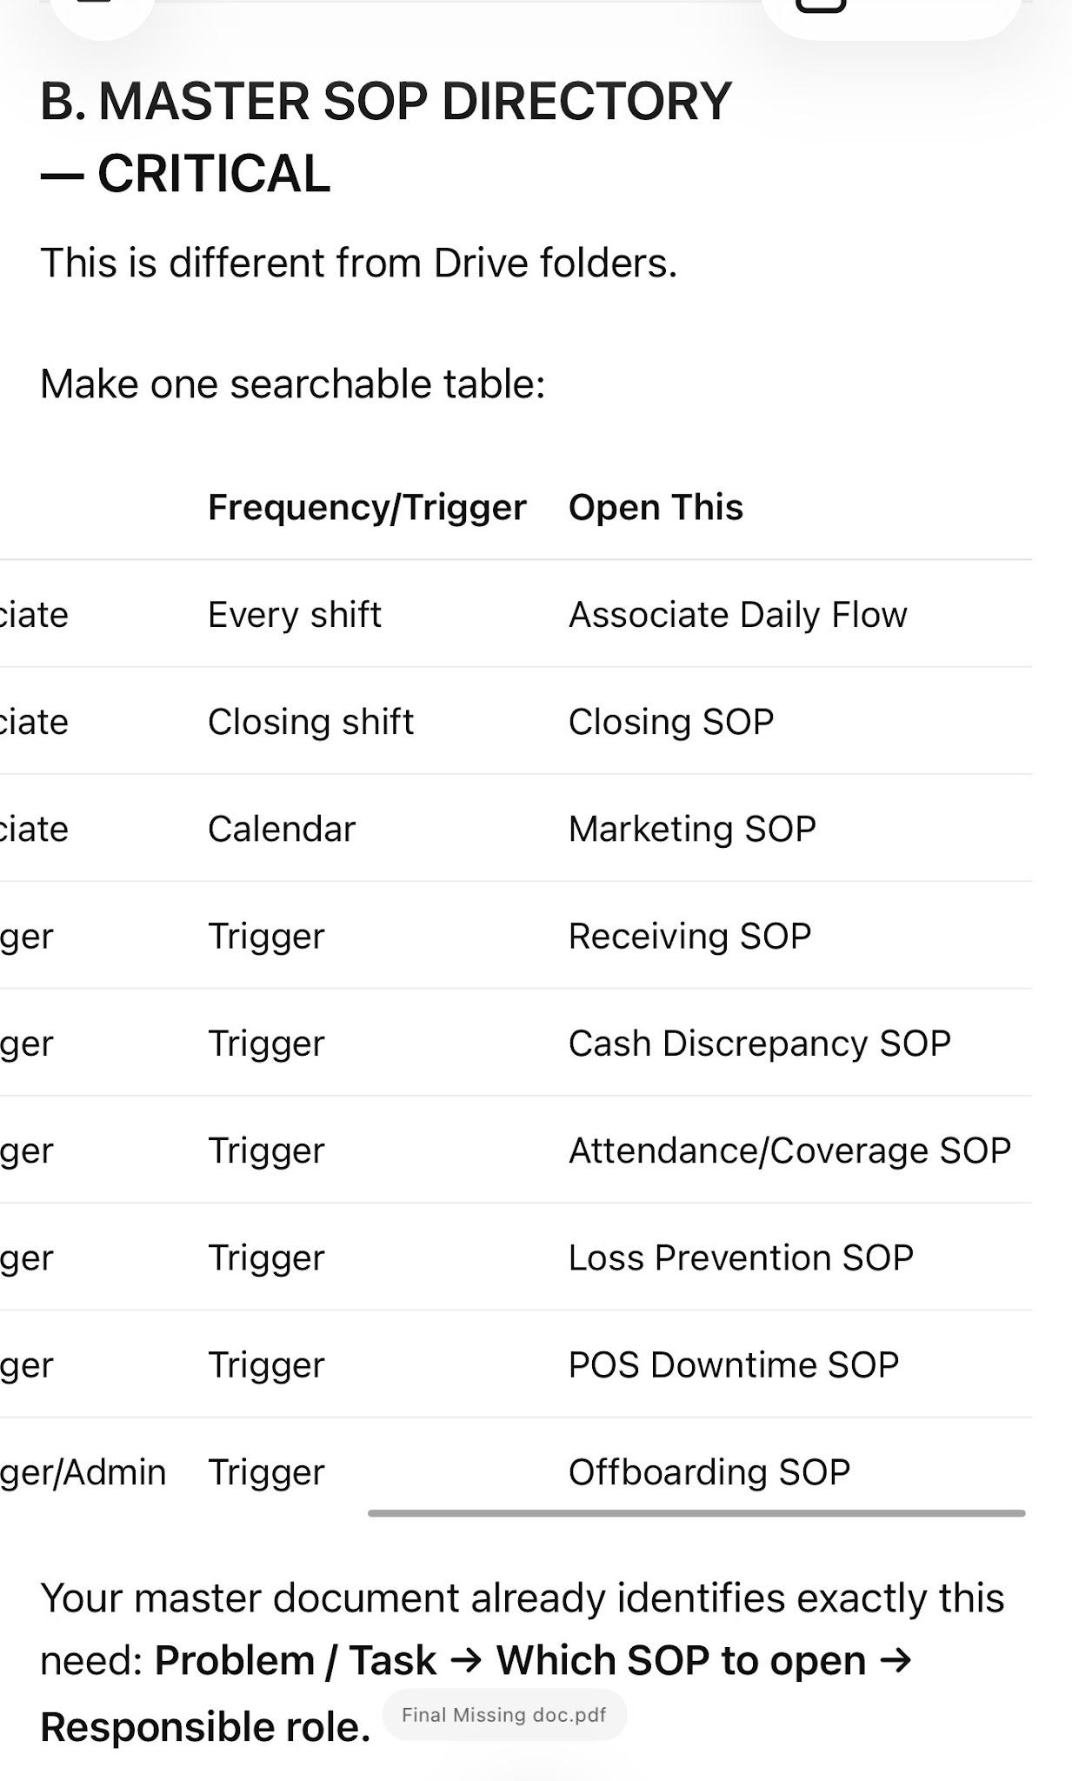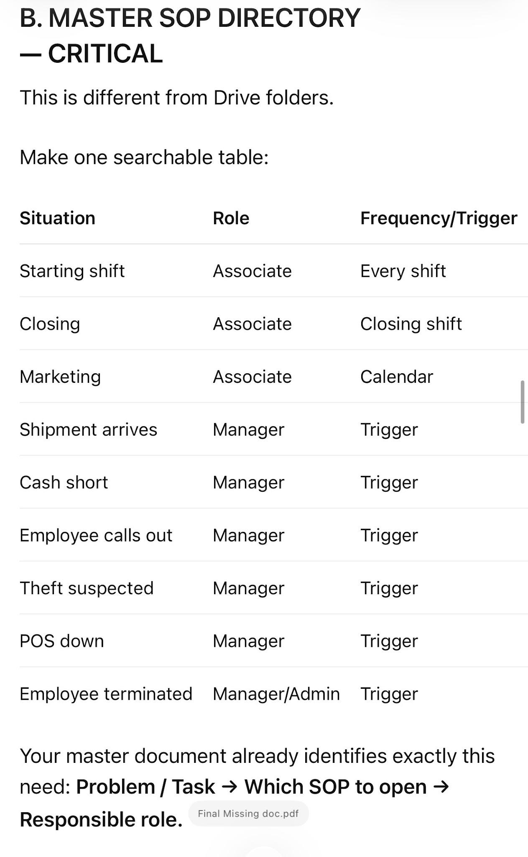

Your master document already identifies exactly this need: Problem / Task → Which SOP to open → Responsible role.
Final Missing doc.pdf
This is how you prevent your system from eventually becoming impossible to navigate.

C. MANAGER VERIFICATION SYSTEM — CRITICAL
This is where I see one of the greatest operational risks.
Your associate marketing system is already detailed. Employees have task deadlines and proof requirements. For example, the marketing SOP explicitly says proof must be submitted by the deadline and management should be able to determine who did it, which store, whether it was correct, and whether it was on time.
04_Marketing.pdf
Good.
But now:
Who checks the manager checked it?
The chain should be:
ASSOCIATE
Executes + proves
↓
MANAGER
Verifies + corrects
↓
OPERATOR
Verifies manager compliance
↓
OWNER
Reviews operator/store outcomes
↓
RANDOM AUDIT
Tests whether reality matches reports
Your master document itself describes this as:
Associate → Manager → Operator → Ownership, plus periodic independent/random audits.
Final Missing doc.pdf
This should be its own company-wide Verification & Audit System, not scattered across SOPs.

D. EXCEPTION COMMAND CENTER
I would create one folder called:

WHEN SOMETHING GOES WRONG
This could become one of the most useful folders in the entire company.
Inside:
Attendance / No Show
Cash Shortage
Employee Theft
Customer Theft
Robbery
Customer Complaint
Refund/Chargeback
Employee Injury
Police / Government Visit
POS Failure
Internet Failure
Power Failure
Store Cannot Open
Shipment Missing/Wrong
Inventory Discrepancy
Product Recall
Maintenance Emergency
Vendor Failure
Employee Conflict
Employee Termination
Key/Alarm Compromise
Data/Security Incident
The master guide already recognizes many of these exceptions.
Final Missing doc.pdf
Managers will use these much more effectively than a 100-page manual they need to search.

E. TRAINING CERTIFICATION — not just training
You have substantial training material.
For example, your manager-trains-employee process has a three-day sequence: general retail/product knowledge, detailed product/sales training, then live sales-floor testing and product-knowledge testing.
Manager trains Employees.pdf
What’s important is closing the loop:
TRAIN → DEMONSTRATE → TEST → PASS → CERTIFY → RELEASE TO WORK → RETEST
Don’t let:
“Manager showed employee the document”
equal
“Employee is trained.”
Create certification standards such as:
Opening certified ✓
Closing certified ✓
POS certified ✓
Cash certified ✓
Product knowledge certified ✓
Sales certified ✓
Marketing certified ✓
Cleaning certified ✓
Compliance certified ✓
Employee cannot independently perform sensitive functions until certified.

F. DOCUMENT CONTROL — extremely important at your scale
You’re going to run into a problem as these documents change:
Store 1 is following Marketing SOP version 2.
Store 4 still has version 1 printed on the wall.
Manager 6 has a screenshot from three months ago.
Employee is trained using an outdated SOP.
Therefore every controlled document needs:
Document ID
Version
Effective Date
Owner
Approved By
Last Review
Next Review
Replaces Version
Affected Roles
Retraining Required?
Your own master document already calls for owner, version/date, last/next review, approval authority, and a way to notify/retrain employees after changes.
Final Missing doc.pdf
For seven stores, I would consider this mandatory.

G. ACCESS MATRIX
Your screenshots show separate “Accesses” folders and Lightspeed, ADP and Connecteam documents.
Take this one step further.
Have one Role Access Matrix:
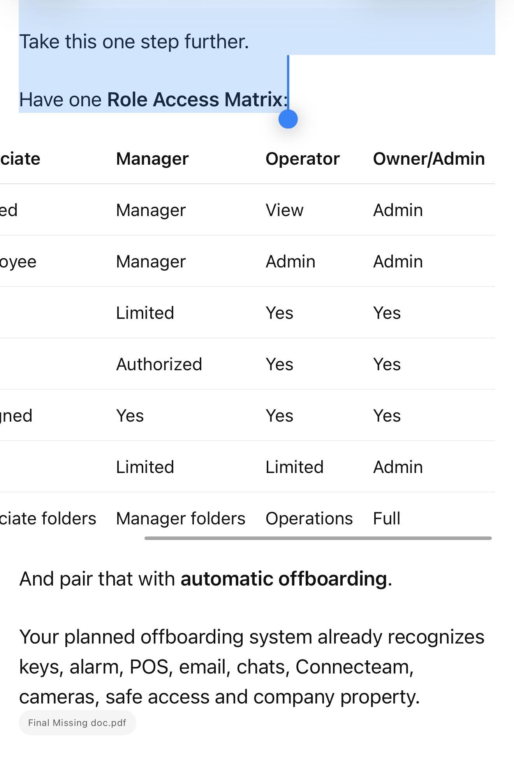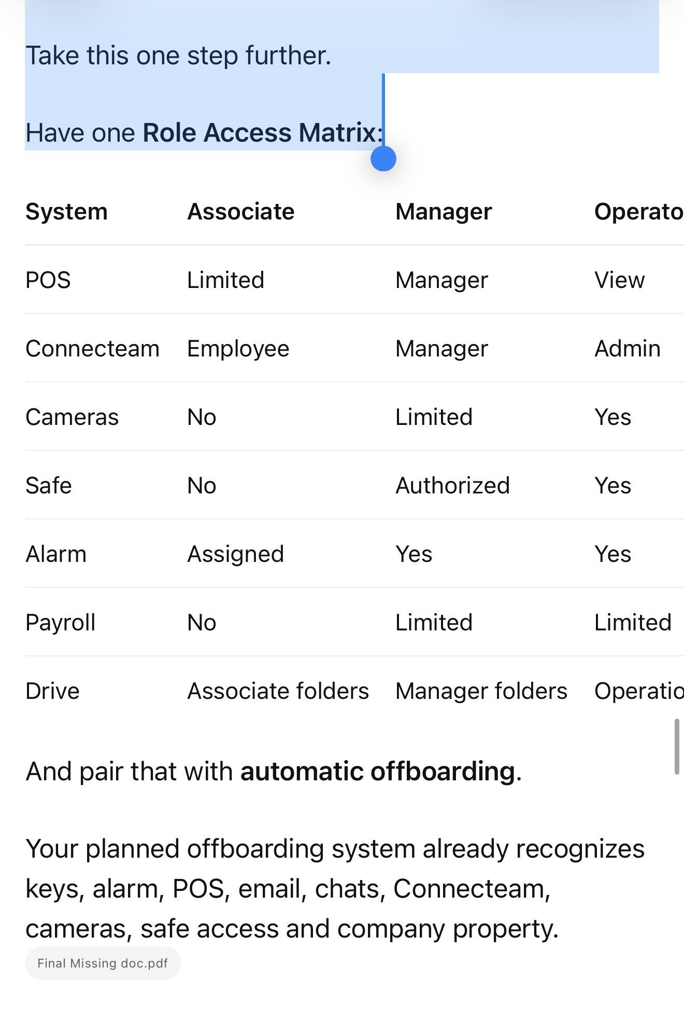And pair that with automatic offboarding.
Your planned offboarding system already recognizes keys, alarm, POS, email, chats, Connecteam, cameras, safe access and company property.
Final Missing doc.pdf

H. ONE SOURCE OF TRUTH
This is one concept I would add very strongly.
You currently have:
Google Drive
WhatsApp
Connecteam
physical wall calendars
PDFs
Google Docs
possibly printed checklists.
That’s workable, but every information type needs one authoritative home.
Example:
SOP: Google Drive
Recurring assignment: Connecteam/Constant Calendar
Proof: designated chat/system
Performance data: dashboard
Employee record: HR file
Incident: incident log
SOP changes: master document register
Never allow two places to both be considered the official source.
Otherwise seven stores eventually produce conflicting information.

I. CLOSED-LOOP CORRECTIVE ACTION
This is different from consequences.
Your system already identifies recurring-problem/root-cause work: record the problem, immediate fix, root cause, process failure, permanent correction, responsible person, deadline and verification.
Final Missing doc.pdf
Make it mandatory.
A recurring problem should travel:
ISSUE
↓
Immediate correction
↓
Root cause
↓
Was SOP followed?
NO → accountability/training issue
YES → SOP/system itself may be defective
↓
Permanent correction
↓
Assign owner
↓
Deadline
↓
Verify
↓
Update SOP if necessary
↓
Train affected people
↓
Recheck 7/30 days later
↓
CLOSE
That is how your operating system actually becomes smarter.

J. A FEW AREAS I WOULD MAKE SURE GET FINISHED
Your missing-doc master already identifies many of these, so I wouldn’t call all of them new ideas. But I would treat them as high-priority completion items:
Employee lifecycle: attendance/call-out/no-show, HR records, handbook/conduct, performance review, promotion/demotion, termination/offboarding. Your current plan is explicitly stronger on hiring/onboarding than offboarding.
Final Missing doc.pdf
Financial controls: opening/closing drawer, discounts, voids, refunds, cash drops, reconciliation, deposits, safe access and investigation thresholds.
Final Missing doc.pdf
Risk: incident reporting, loss prevention, CCTV/evidence retention, product recall, cybersecurity/data privacy, emergency response.
Facilities: maintenance request → priority → owner → vendor → deadline → proof → closeout. Your master already covers HVAC, plumbing, electrical, locks, cameras, POS equipment, internet, pest control, preventive maintenance and repair escalation.
Final Missing doc.pdf
Field audits: every above-store visit should use the same categories and end with PASS / FAIL / CORRECT BY / RESPONSIBLE PERSON / PROOF REQUIRED.
Final Missing doc.pdf

The final architecture I would build
This is where I think your concept becomes substantially cleaner.

RETAIL OPERATING SYSTEM

00 — START HERE
Master System Map
Master SOP Directory
Company Chain of Command
Document Control Register

01 — SALES ASSOCIATE
A — DAILY / RECURRING
Start Shift
Sales
Marketing
Cleaning
Merchandise
Shift Handoff
Closing
Daily Checklist
B — WHEN IT COMES UP
Customer Complaint
POS Problem
Suspicious Activity
Cash Issue
Emergency
etc.
C — TRAINING / REFERENCE
General Retail
Product Knowledge
Sales
Marketing
POS
Compliance

02 — MANAGER
A — DAILY
Manager Opening Dashboard
Staffing
Associate Verification
Marketing Verification
Cleaning Verification
Merchandise/Inventory Check
Cash Controls
Maintenance Check
Manager Tasks
EOD Verification
B — WEEKLY
Inventory
Training
Performance
Audits
Scheduling
Store Standards
Marketing Review
C — MONTHLY
Employee reviews
Store audit
Access audit
System review
Inventory controls
D — WHEN IT COMES UP
Hiring
Training New Hire
Call-Out
Termination
Theft
Cash shortage
Complaint
Maintenance
Emergency
Shipment
etc.

03 — OWNER / OPERATOR
DAILY
Exceptions dashboard
Critical alerts
Manager compliance
Store KPIs
WEEKLY
7-store scorecard
Manager performance
Sales
Inventory
Marketing
Cash exceptions
Staffing
Outstanding corrective actions
MONTHLY
Store ranking
Manager review
Financial review
System health
SOP audit
Access audit
Recurring problem review
QUARTERLY
Full operational audit
Compliance review
Leadership pipeline
Systems simplification
Strategic improvement

04 — BACKEND / OFFICE
Payroll
Accounting
Bills
Invoices
Purchasing
Vendor management
Document control
HR records
Reporting
Licensing
Compliance administration

05 — EXCEPTIONS / EMERGENCIES
One company-wide “What If?” system.

06 — MASTER CONTROL
SOP Register
Versions
Audits
Corrective Actions
Recurring Problems
Store Scorecards
Manager Scorecards
Training Certifications
Access Matrix
System Change Log

The single biggest mistake to avoid
Do not confuse having a PDF with having a system.
Your marketing materials demonstrate the distinction very well.
The marketing SOP says what to do and how to prove it.
04_Marketing.pdf
The Marketing Constant Calendar tells the employee when, including timed responsibilities such as daily stories, affiliate marketing and physical marketing.
Your Associate Checklist adds accountability and manager verification.
EMPLOYEE REPORTS.pdf
That combination is a system.
Apply that exact philosophy to everything:
SOP + ROLE + TRIGGER/TIME + CHECKLIST + PROOF + VERIFICATION + KPI + FAILURE RESPONSE + AUDIT + IMPROVEMENT
= actual operating system.
If you build those layers across your existing master categories, I would stop aggressively brainstorming additional SOPs. Your master document is already broad enough. At that point, the goal becomes completing, connecting, simplifying, implementing, testing and auditing what you already identified.
Your own document reaches essentially this conclusion too: stop adding documents merely to have more documents; create the master index, consolidate overlap, and let recurring real-world failures reveal the remaining gaps.
Final Missing doc.pdf
So yes: there are still pieces to finish, but I don’t see a giant missing department in the concept. The biggest missing piece is turning the collection of SOPs into one closed-loop operating architecture that makes it nearly impossible for a responsibility to disappear between employee → manager → operator → owner.

The system you are building is very good overall. I would keep the fundamental concept. I would not replace it with a completely different system.
But I would upgrade it one more level.
The best version is not an SOP system. It is a Retail Execution & Control System.
Your current documents already discovered the core principle:
DOCUMENT → ASSIGN → EXECUTE → PROVE → SUPERVISE → AUDIT → MEASURE → CORRECT → IMPROVE → UPDATE → REPEAT.
Final Missing doc.pdf
That is very close to how I would design the company from scratch. Current multi-location retail operations guidance similarly emphasizes that SOPs alone aren’t enough: standardized tasks, verification, corrective-action closure, role-based responsibility, centralized documents, and dashboards are what turn standards into actual execution.

The one major upgrade I recommend
I would organize the company around three interconnected systems, rather than treating everything as one giant SOP library.

SYSTEM 1 — KNOWLEDGE SYSTEM
“How should the company operate?”
This contains:
Policies
SOPs
Training
Product knowledge
Sales standards
Marketing procedures
Hiring procedures
Cash procedures
Inventory procedures
Emergency procedures
Manager procedures
Reference material
This is your company brain.
People open this when they need to learn something or understand how something works.

SYSTEM 2 — EXECUTION SYSTEM
“What does everyone need to do right now?”
This is what employees and managers actually live inside.
Associate Daily Flow
Manager Daily Flow
Operator Daily Flow
Opening checklist
Closing checklist
Cleaning calendar
Marketing calendar
Inventory tasks
Manager tasks
Weekly tasks
Monthly tasks
And then:
WHEN X HAPPENS → automatically use X procedure.
Shipment arrives → Receiving SOP
Employee calls out → Coverage SOP
Employee hired → Onboarding workflow
Employee terminated → Offboarding workflow
Cash short → Cash Discrepancy SOP
Customer complaint → Complaint SOP
POS down → Downtime SOP
Theft suspected → Loss Prevention SOP
The critical distinction is:
Knowledge system = what/how.
Execution system = who/when.
Your documents already move strongly in this direction by separating recurring work from “when it comes up” work and calling for separate master flows for employees, managers and owners.
Final Missing doc.pdf

SYSTEM 3 — CONTROL SYSTEM
“How does ownership know Systems 1 and 2 are actually working?”
This is the piece I would emphasize most.
Associate completes
↓
Manager verifies
↓
Operator verifies manager
↓
Independent/random audit
↓
Scorecard measures result
↓
Problem gets flagged
↓
Corrective action assigned
↓
Deadline established
↓
Recheck occurs
↓
Problem closes OR escalates
↓
Recurring problem triggers root-cause analysis
↓
System/SOP changed if necessary
This is your control tower.
Your documents already recognize the chain:
Associate → Manager → Operator → Ownership, together with independent/random auditing.
Final Missing doc.pdf
I would make that one of the most important systems in the entire company.

The final model
Think of your seven stores like this:
COMPANY STANDARDS
↓

KNOWLEDGE
“What is the correct way?”
↓

EXECUTION
“Who does what and when?”
↓

PROOF
“Did they actually do it?”
↓

SUPERVISION
“Did the manager verify it?”
↓

CONTROL
“Did the manager/operator actually maintain the system?”
↓

PERFORMANCE
“Did the system produce the desired result?”
↓

CORRECTION
“What isn’t working?”
↓

IMPROVEMENT
“How do we prevent it from happening again?”
↓
UPDATED COMPANY STANDARD
↓
Repeat forever.
That is stronger than merely saying “we have an SOP for everything.”

There are 6 principles I would make non-negotiable
These are more important than adding another 30 documents.

1. Every responsibility has ONE primary owner.
Never:
Billy and manager should handle inventory.
Instead:
Manager owns store inventory accuracy.
Operator supervises it.
Associate executes assigned counts.
If everybody owns something, nobody truly owns it.

2. Every recurring responsibility appears automatically.
Employees should not remember systems.
The system remembers for them.
Monday 10 AM → task appears.
Closing → checklist appears.
30th → monthly system audit appears.
New hire → onboarding workflow starts.
Shipment arrives → receiving workflow starts.
The strongest multi-location systems increasingly use recurring role-based task assignment and escalation rather than relying on individual managers to remember requirements.

3. Manage by exception.
This is a major improvement I would make for you as owner.
You should NOT spend your day looking through:
7 stores × 20 tasks = 140 completed tasks.
You should see:
GREEN — 132 completed correctly
RED — 8 exceptions
Then:
Store 2 — cash variance
Store 4 — manager missed audit
Store 5 — inventory discrepancy
Store 6 — marketing missed
Store 7 — maintenance overdue
Your attention goes to the 8 failures, not the 132 successes.
That is how your system can scale beyond seven stores.

4. Proof is not the same as performance.
This distinction is extremely important.
Employee posts flyer photo.
Proof: flyer was distributed.
But:
Did traffic increase?
Employee posted social content.
Proof: content was posted.
But:
Did views/followers/store visits improve?
Manager says inventory was completed.
Proof: count exists.
But:
What is inventory accuracy/shrink?
So measure BOTH:
Execution KPI
Did the system happen?
AND
Outcome KPI
Did it produce the result?
Your Progress document already pushes toward ownership measuring results rather than simply asking whether an activity occurred.
progress.pdf

5. Never let a failure disappear.
This might be the most important rule in your entire company.
NO OPEN LOOP MAY DISAPPEAR.
Something wasn’t completed?
It doesn’t vanish tomorrow.
It becomes:
OPEN ISSUE
Owner: John
Problem: Missing merchandise count
Original deadline: Tuesday
Corrective deadline: Wednesday 12 PM
Status: OPEN
Escalation: Manager
Proof required: Count sheet
Tomorrow:
Still unfinished?
ESCALATE.
Your Unfinished Work system already proposes essentially this: reason → new deadline → responsible person → escalation → follow-up.
Final Missing doc.pdf
I would make this company-wide.

6. The system must continuously simplify itself.
This sounds counterintuitive because you’re building more documents.
But every monthly system review should ask:
What can we DELETE?
Not just:
What should we ADD?
Ask:
Is this SOP actually used?
Does this checklist duplicate another?
Does this report cause an action?
Can this task be automated?
Can two documents become one?
Is management collecting information nobody looks at?
Is this requirement worth employees’ time?
Current operations guidance warns that poorly designed processes remain poor even when digitized and that audits/KPIs should drive action rather than bureaucracy.
That’s extremely relevant to what you’re building.

What I would NOT do
I would not try to make the system so detailed that employees need to read 30 pages every shift.
That’s where a sophisticated system can actually become worse.
An associate should primarily see:
TODAY
8 tasks.
Not:
Here’s our 350-page Retail Operations Manual.
The 350-page system exists behind those eight tasks.
Same for managers.
Their daily interface should be simple even though the backend system is extremely sophisticated.
That’s one of the most important design principles I’d use.

And I would not have ownership micromanage seven stores
Your architecture should eventually look like:
OWNER
↓
OPERATING PARTNER / OPERATIONS LEADER
↓
7 STORE MANAGERS
↓
SHIFT LEADS / ASSOCIATES
The owner manages:
People
Numbers
Exceptions
Major decisions
Manager/operator performance
Systems
Growth
The owner shouldn’t be checking whether Store #4 cleaned a showcase Tuesday night.
If that reaches ownership regularly, the manager/operator control layer failed.
Your own system correctly says your role should increasingly become supervising the supervisors, rather than personally supervising every SOP.
Final Missing doc.pdf

I would also add one very powerful measurement

STORE HEALTH SCORE
Every store gets a weekly score, for example:
Sales Performance — 25%
Inventory/Shrink — 15%
Employee/Staffing — 10%
Marketing Execution — 10%
Cleaning/Store Standards — 10%
Cash Controls — 10%
SOP Compliance — 10%
Customer Experience — 5%
Maintenance/Compliance — 5%
= 100% STORE HEALTH
Then:

90–100
Excellent

80–89
Healthy

70–79
Needs attention

<70
Corrective Action Plan
You already planned store ranking/performance comparison and corrective plans for persistently underperforming stores.
Final Missing doc.pdf
I would turn that into one of ownership’s primary views.

Then have a Manager Health Score
Separate from store performance.
Because a manager can temporarily inherit a bad store.
Measure:
Task completion
Proof accuracy
Employee management
Training completion
Store standards
Inventory accuracy
Communication
Deadline compliance
Sales improvement
Problem resolution
Audit performance
Repeat failures
Now you’re measuring both:
STORE PERFORMANCE
and
PERSON RESPONSIBLE FOR STORE PERFORMANCE.
That makes accountability much cleaner.

One more major improvement: test it before calling it finished
Don’t finish all the PDFs and immediately deploy everything across seven stores.
I would take one store and run the entire operating system for 2–4 weeks.
Pretend ownership cannot intervene.
Observe:
What questions does manager ask?
What does employee misunderstand?
Which SOP can’t they find?
Which task gets forgotten?
What requires owner intervention?
What proof is fake/useless?
What takes too long?
What checklist is annoying?
What isn’t being supervised?
What problem has no SOP?
What SOP isn’t practical in reality?
Then fix it.
Then test at a second store.
Then standardize across seven.
Current multi-location guidance similarly recommends piloting a subset of locations, refining workflows, standardizing audits, and only then expanding.
That is how you find the gaps that brainstorming will never reveal.

So, is there a better system?

Not fundamentally.
I wouldn’t throw yours away and replace it.
I’d evolve it from:
“We have an SOP/document for everything.”
into:

THE 7-STORE RETAIL EXECUTION & CONTROL SYSTEM
Built on three engines:
1. KNOWLEDGE
How everything works.
2. EXECUTION
Who does what, when, with what proof.
3. CONTROL
Verification, audits, KPIs, exceptions, accountability and continuous improvement.
And underneath everything:
STANDARD → ASSIGN → EXECUTE → PROVE → VERIFY → MEASURE → FLAG EXCEPTION → CORRECT → RECHECK → IMPROVE
If you get that architecture working properly, I would consider it a genuinely strong operating model for seven stores. More importantly, it would be designed so adding store #8, #15, or #30 does not require ownership to proportionally increase its involvement.
The real test of whether you’ve succeeded isn’t “Do we have an SOP for everything?”
It’s:
Can an ordinary competent manager run one of these stores correctly for 30 days without asking ownership how to handle routine operations—and can ownership know which of the seven stores is slipping without personally visiting or chasing people for answers?
If the answer becomes yes, your system is doing what it’s supposed to do.

_____________________________________________

_____________________________________________

_____________________________________________

1. The owner Must Own Outcomes, Not Tasks
Don't measure:
- "Did marketing happen?"
Measure:
- Was every store at 100% marketing compliance?
- If not, why?
- Who is responsible?
- What is the correction?
The operating partner should own the result, even if a manager failed.

2. Every Responsibility Needs an Owner
Nothing should ever say:
Marketing wasn't completed.
Instead:
Store 4
Task:
Flyer distribution
Owner:
John
Due:
Wednesday
Status:
Late
Reason:
Employee absent
Correction:
Manager assigned replacement.
If a task doesn't have an owner, it usually doesn't get done.

3. Every KPI Needs a Threshold
Avoid vague goals like:
- Increase sales
- Improve marketing
- Better inventory
Instead define success.
Example:
Marketing
- Every store completes 100% of scheduled marketing.
Inventory
- Zero fast-moving items out of stock for more than 24 hours.
Manager audits
- Every manager receives one coaching session weekly.
Restocks
- Completed within 24 hours of reaching reorder point.

4. Red Flags Should Be Automatic
The owner shouldn't decide what deserves attention.
Predetermine it.
Examples:
🔴 Immediate attention:
- Marketing missed
- Out-of-stock fast seller
- Manager no-show
- Cash shortage
- Failed audit
- Google rating drops below target

5. Weekly Follow-Up on Last Week
This is one of the biggest missing pieces in most systems.
Every weekly report should start with:

Last Week's Commitments
Task | Completed? | If Not, Why?
If something rolls over for three weeks, that's a leadership issue.

6. Require Evidence, Not Statements
Don't accept:
"Marketing completed."
Require:
- Photos
- GPS check-ins (if practical)
- Receipts
- Audit sheets
- Manager signatures
- Inventory reports
Evidence dramatically reduces misunderstandings and improves accountability.

7. The Owner Should Spend Most Time on Leadership
A common mistake is making them a firefighter.
Instead, measure things like:
- Managers coached
- Managers developed
- Weak managers improved
- Future leaders identified
- Systems improved
- Bottlenecks removed
If they're always solving today's problems, they're not building tomorrow's business.

8. Have a "System Health" Report
Every Friday, ask one question:
What part of our operating system is breaking?
Examples:
- Marketing system failing because managers don't schedule employees.
- Inventory system failing because reorder points are wrong.
- Training system failing because onboarding takes too long.
Fix systems, not just incidents.

The Biggest Thing I Think Is Missing
Everything you've listed measures execution.
You're not yet measuring improvement.
An owner should leave the business better every month than they found it.
I'd require these deliverables every week:
- One process improved.
- One cost reduced.
- One revenue idea implemented.
- One manager developed.
- One system documented or updated.
- One recurring problem permanently solved.
If none of those happened, then the business likely just maintained itself rather than improving.

Finally: Build the System Around Routines, Not Motivation
This is where many businesses struggle.
Don't rely on reminders or willpower.
Instead, establish fixed rhythms:
- Every morning: Store priorities reviewed.
- Every Tuesday: Merchandise and inventory review.
- Every Wednesday: Marketing verification.
- Every Thursday: Manager coaching and audits.
- Every Friday: Executive report, KPI review, and next week's plan.
When everyone knows what happens on each day, execution becomes part of the operating rhythm rather than something that depends on memory.

The One Principle I'd Build Everything Around
Ask this question for every report, KPI, or meeting:
"What decision will this allow me to make?"
If a report doesn't lead to a clear decision or action, remove it. If it does, keep it. That keeps the system lean, practical, and sustainable.
For a 7-store operation, a great system isn't the one with the most paperwork—it's the one where, in 15–20 minutes each week, you can accurately answer:
- Are sales and profits improving?
- Is marketing being executed consistently?
- Are managers being actively led and held accountable?
- Are inventory and merchandising systems working?
- What are the biggest risks right now?
- What are the biggest opportunities?
- Is the operating partner improving the business, not just maintaining it?
If those questions can be answered quickly with objective data and clear ownership, you've built a system that's much more likely to last.

